GUI Design Differences

Face Design

When you design something that is complicated, you mind brings forth the most attractive shapes – faces.

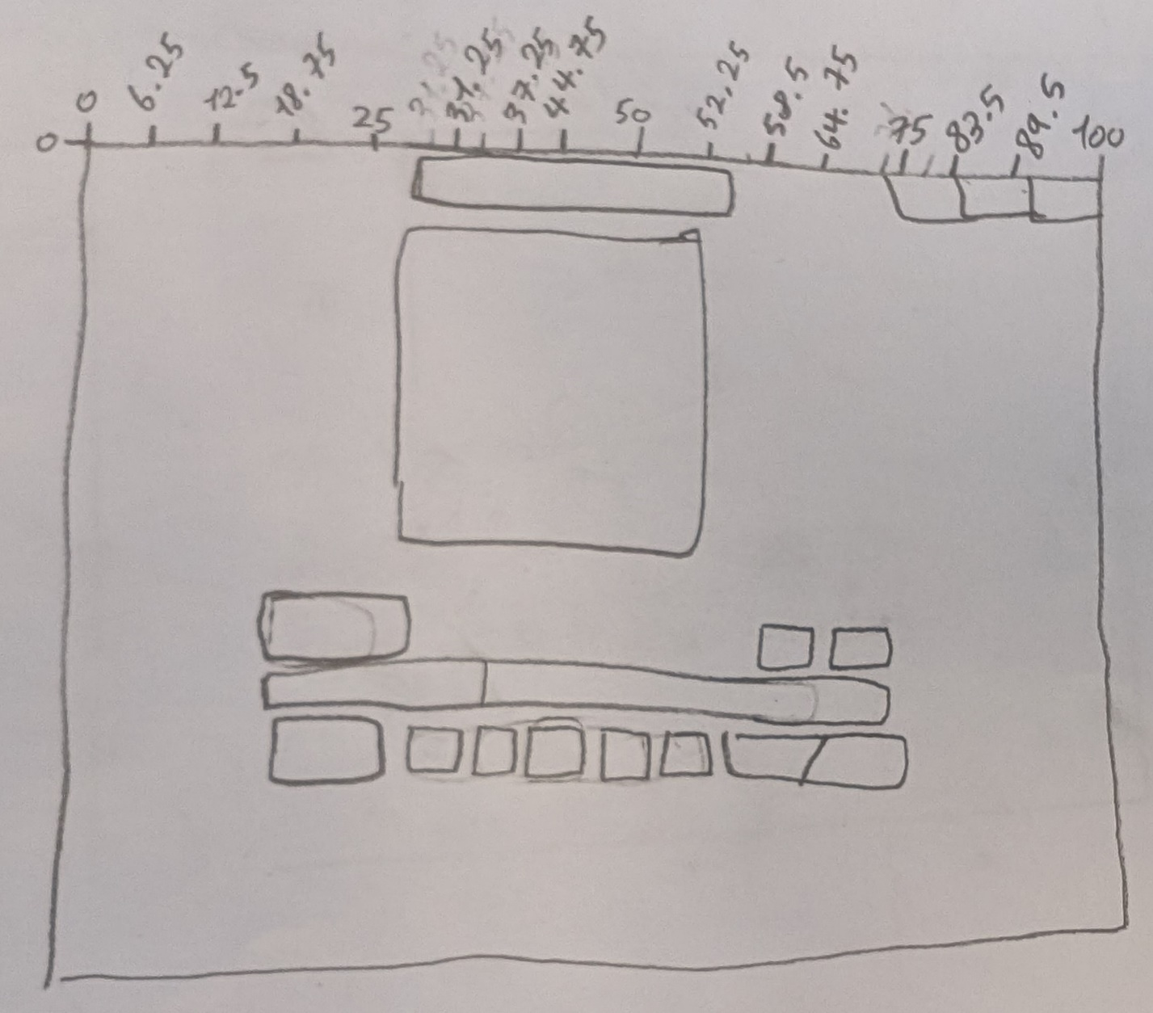

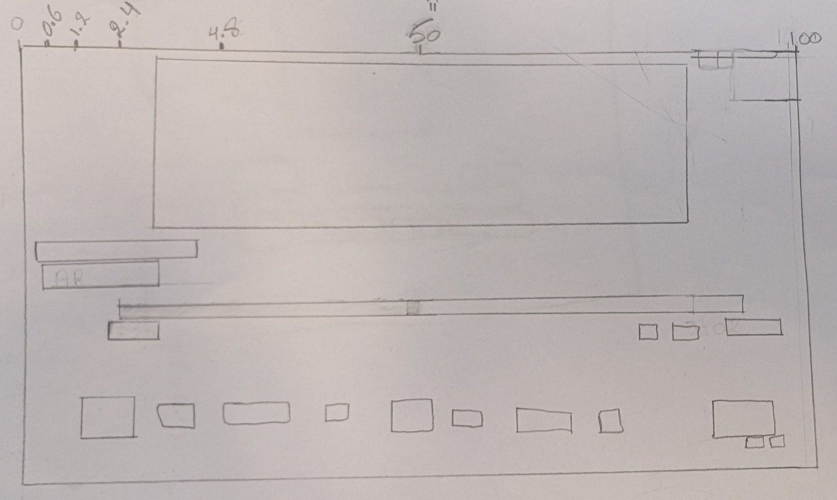

**X & Y Only**

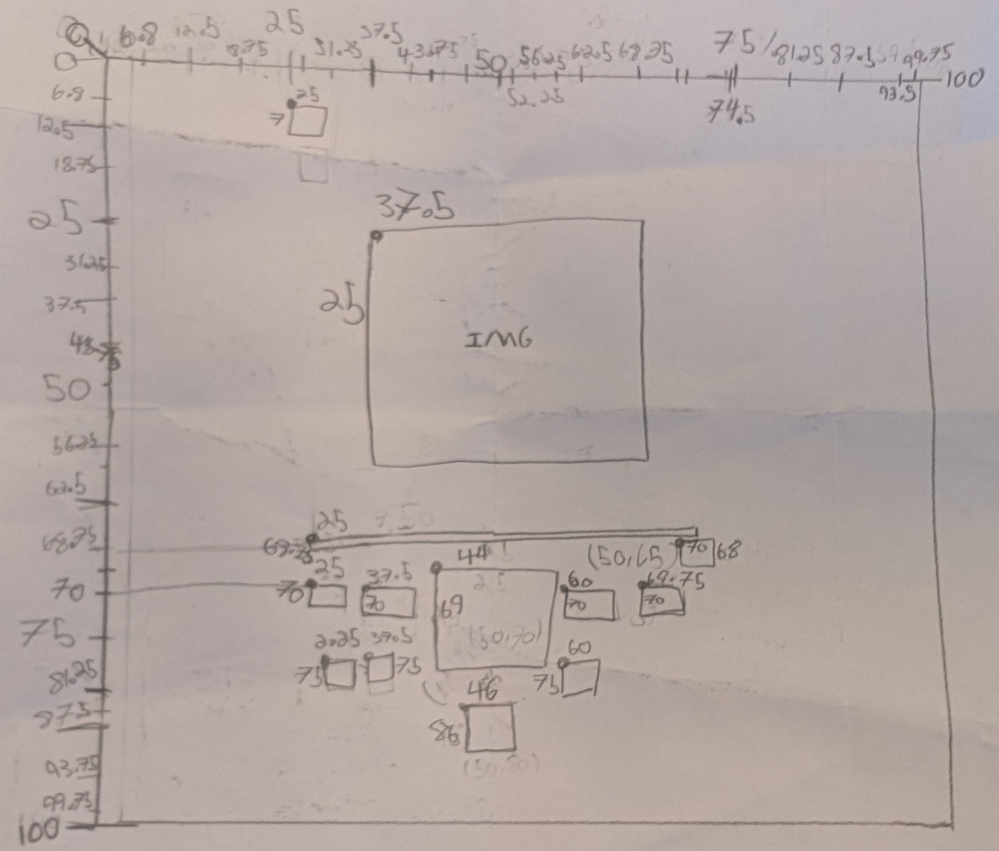

Repetition Design

How a computer thinks about numbers the easiest. Called patterned logical thinking or Computational Theory.

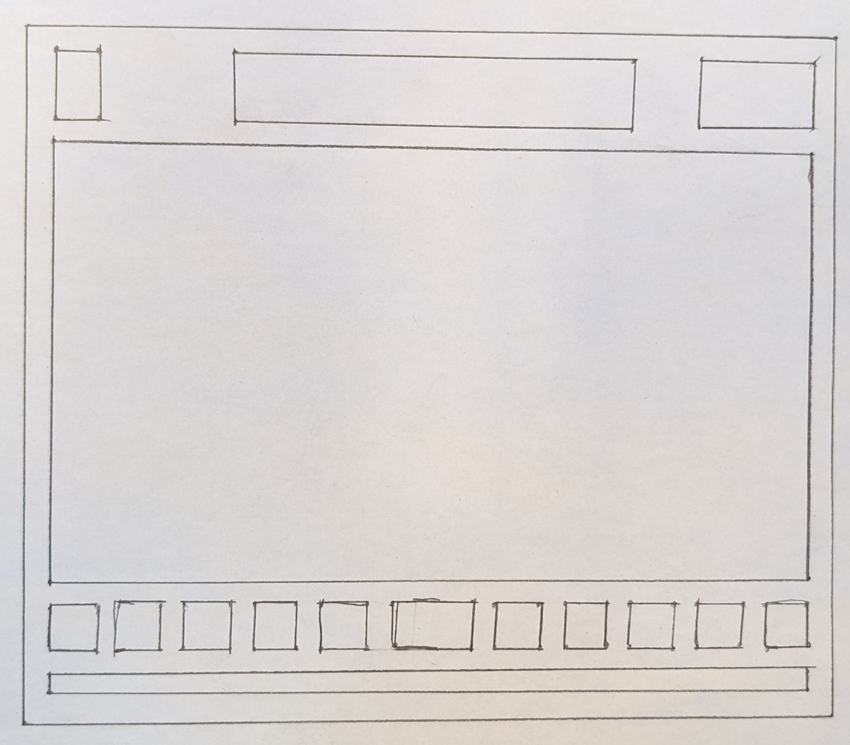

The overlay with a grid underneath. This creates a high degree of symmetry.

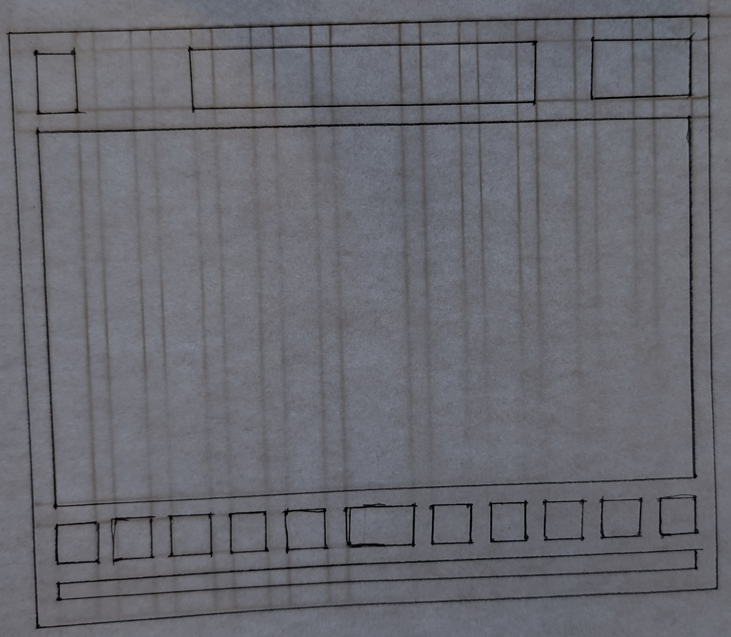

Only the grid

